Date
18th February 2021 | Page 1 of 1

For immediate release


Factors to consider when choosing lighting for offshore wind energy applications

When selecting lighting for an offshore wind farm, a number of important factors should be considered, including maintenance, energy costs and quality of light to minimise downtime, says Gordon Low of Glamox.
Offshore wind projects normally require five years’ warranty from float out or even commissioning the farm, so it is critical to supply high quality products that can withstand this time out at sea, particularly as replacement costs on offshore wind farm projects are extremely high. Operation and maintenance activity accounts for approximately 25% of the lifetime cost of an offshore wind farm.

Marine lighting and light management systems from Glamox are beneficial choices for offshore wind farm operators, maintenance contractors, installers and consultants. Glamox has decades of experience in the design and manufacture of lighting solutions for harsh operating environments. Offshore wind installations require state of the art lighting products that meet regulations and are tested and certified to meet the challenging conditions. Lighting solutions from Glamox are based on the best technology available on the market and are easy to plan, install, commission and use.

Typical applications for lighting include walkways, stairways and ladders, crew access, control room, doorways and the turbine identification board. Before making a choice on lighting, a number of factors should be considered for each application, from the control room and turbine down to the foundations:

Nacelle/Control Room
Safe access to the nacelle is required for most maintenance activities. Although ladders are always required, larger wind turbines also have an elevator. To protect all nacelle components from corrosion, the nacelle is well sealed. The nacelle cover provides weatherproof protection to the nacelle components, as well as support and access to external components. Reliable, high quality lighting is required to facilitate safe personnel access and exit from the nacelle and tower.

In a confined space, it is an advantage to have low profile luminaires, as space is a challenge when performing work tasks inside the control room. Lighting is normally fitted to the ceiling or walls, with exit lights installed at doorways. Emergency lighting is also required to maintain safety in the event of a loss of grid power. Lighting should be marine-tested and quality approved.

Turbines/Towers
The design life of an offshore turbine is around 25 years. The trend for longer design life on all turbines is due to the maturing of the industry – asset owners now expect to operate wind farms for such periods without the technology becoming obsolete or unsupported by suppliers. Extreme loads due to storms, abnormal events and faults during operation can also be critical. Typically, an offshore turbine will turn for over 90% of the time, so it is important to choose a lighting supplier that has plenty of experience of marine and offshore environments and luminaires that will achieve the intended lifetime of the turbines.

The tower internals provide means of access, lighting and safety for maintenance and service personnel, as well as a means of transferring hand tools and components to the nacelle. Lighting is normally fitted to ladders, platforms and handrails, with exit lights installed at doorways. Emergency lighting is also required to maintain safety and in the event of a loss of grid power.

Foundations/Transition Piece
The floating or fixed foundations provide support for the wind turbine, transferring the loads from the turbine at the tower interface level to the sea bed where the loads react. The foundation also provides access for personnel from vessels. Unregulated vibrations result in excessive material wear, which in turn can (and does) cause component failure. A lighting supplier should therefore offer vibration testing of the light fixtures. Glamox, for example, performs three types of test: Sinusoidal vibration, various shock/impact tests, and random testing.

Lighting should be installed at the crew access point to the foundation, as well as lighting the escape to sea. This area sits above the supportive structure and is accessed via a bridge from the crew transfer vessels. Therefore, safety requirements dictate that high quality marine lighting is needed to ensure these areas are well lit. Typically, linear lighting will be installed on handrails, floodlights for lighting the escape to sea and for illuminating the turbine identification plate, as well as part of the turbine.

Substation topsides AC and HVDC
The substation is the most important structure in an offshore wind farm. This is where all the energy produced by the wind turbines is brought together and converted by transformers to a high voltage transmission. This is necessary to ensure that as little energy as possible is lost during transmission over long distances to the next grid node.

If a technical fault occurs on the substation platform, all wind turbines in the offshore wind farm will fail to function. This means that maintenance and repair services must meet extremely meticulous and high quality standards. All electrical products, including lighting, are potential emitters of electromagnetic waves. This means that lighting should be marine-certified and tested according to both EN-55015 and EN-61547.

On a substation, typical application areas for lighting include linears installed on handrails; floodlights for escape to sea; floodlights to illuminate the substation identification plate and working/lay down areas; and emergency lighting to maintain safety in the event of a loss of grid power. Lighting will also be required for the helideck, battery rooms, switchgear rooms, winch platform, cabins, containers, Davit crane and for crew access. Ideally, choose a supplier with lots of experience in the marine and offshore industries that can also provide a one-stop shop selection of all the various types of lighting required for the substation.

For more information on lighting for offshore wind energy applications, please visit Applications - Glamox Offshore Energy

About Glamox AS
Glamox is a Norwegian industrial group that develops, manufactures and distributes professional lighting solutions for the global market. The Glamox Group is a leading supplier to the world’s marine, onshore and offshore markets, and a significant supplier to the professional building market in Europe.
The Glamox Group is a global organisation, with more than 2,400 employees within sales and production in several European countries, as well as Asia, North and South America. The turnover is NOK 3.1 billion. The Group owns a range of quality lighting brands including Glamox, Aqua Signal, Norselight, Luxo, LINKSrechts, Küttel, Luxonic and ES-SYSTEM. Glamox is committed to meeting customer needs and expectations by providing quality products and solutions, service and support. www.glamox.com
Captions for Photographs:
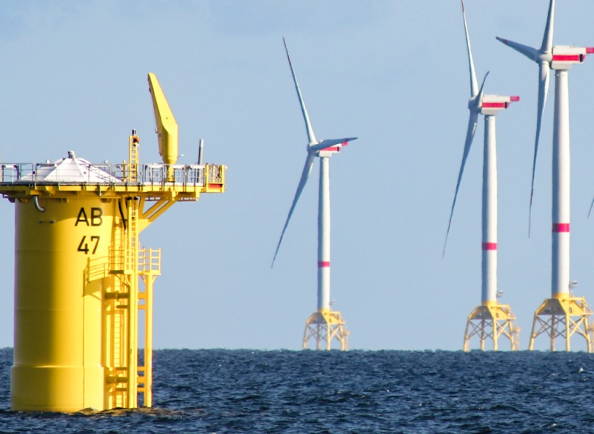
An offshore turbine typically turns 90% of the time, so it is key to choose a lighting supplier that has experience of marine and offshore environments and luminaires that will achieve the intended lifetime of the turbines.

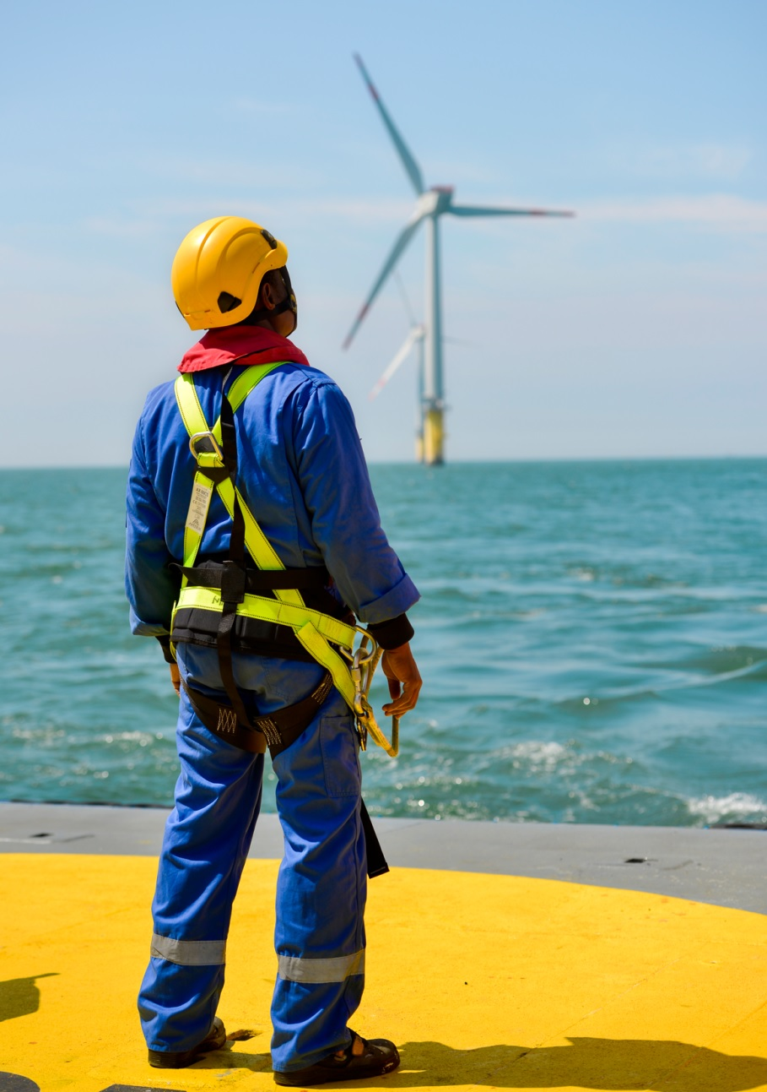

Operation and maintenance activity accounts for around 25% of the lifetime cost of an offshore wind farm.
Contact information
For more information, please contact:

Glamox International
Tel: +44 (0) 7719 547 175
Service.gi@glamox.com
www.glamox.com/gmo
Press Release Issued by:
Dean Palmer, Director, SilverBullet PR Ltd,
19, Glen Crescent, Stamford,
Lincolnshire PE9 1SW
Tel: +44 (1780) 764 254
Mobile: +44 (7703) 023771
dean@silverbulletpr.co.uk
www.silverbulletpr.co.uk
High resolution images are available on request from SilverBullet PR.

